Brainstorm & Idea Prioritization Template

Date | 21 December 2025
Team ID | LTVIP2026TMIDS35979
Project Name | Heart Disease Analysis
Maximum Marks | 4 Marks

Brainstorm & Idea Prioritization Template:
Brainstorming provides a free and open environment that encourages everyone within a team to participate in the creative thinking process that leads to problem solving. Prioritizing volume over value, out-of-the-box ideas are welcome and built upon, and all participants are encouraged to collaborate, helping each other develop a rich amount of creative solutions.
Use this template in your own brainstorming sessions so your team can unleash their imagination and start shaping concepts even if you're not sitting in the same room.
Reference: https://www.mural.co/templates/brainstorm-and-idea-prioritization
Step-1: Team Gathering, Collaboration and Select the Problem Statement
Our team discussed different project ideas related to healthcare and data analytics. After evaluating multiple options, we selected Heart Disease Analysis as our problem statement.
Heart disease is one of the leading health issues worldwide. By analyzing patient data such as age, cholesterol level, blood pressure, and other medical attributes, we aim to identify patterns and major risk factors.
We decided to implement this project using Tableau to create interactive dashboards and generate meaningful visual insights.



Step-2: Brainstorm, Idea Listing and Grouping
During brainstorming, we generated several ideas related to heart disease data analysis:
- Analyze the relationship between age and heart disease risk
- Compare heart disease occurrence between male and female patients
- Study the impact of cholesterol levels
- Analyze blood pressure trends
- Identify key risk factors contributing to heart disease
These ideas were grouped into demographic analysis and medical parameter analysis for better understanding.

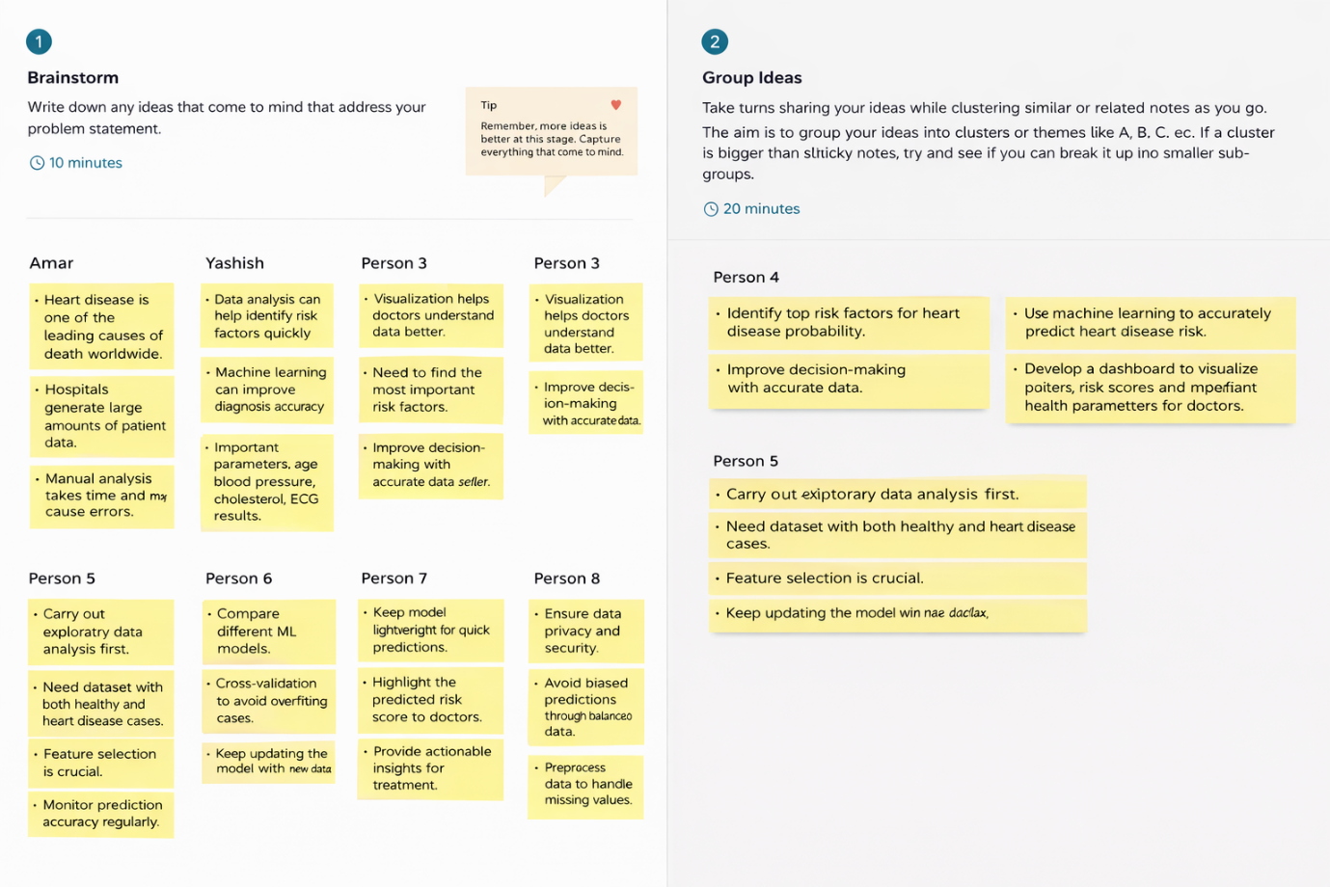

Step-3: Idea Prioritization
After reviewing all ideas, we prioritized the analyses that provide the most meaningful insights. We focused on:
- Identifying significant medical risk factors
- Comparing demographic factors such as age and gender
- Creating clear and interactive dashboards for easy interpretation
The final priority was to build a Tableau dashboard that effectively presents heart disease patterns and insights.

